
Internship Report

Specialty: Computer Science and Technology
Class : 20lq
Student No: 2011561111
Name: FAHIM MD

Internship date 05 Dec 2023
Table of Contents
Acknowledgement - 1 -
Executive Summary - 1 -
COMPANY OVERVIEW - 2 -
WEEKLY OVERVIEW OF INTERNSHIP ACTIVITIES - 5 -
1 First week internship report - 5 -
Fundamental Technologies - 5 -
Supportive Technologies - 6 -
Technology In Use for the Projects - 6 -
Environmet Setup - 6 -
To set up a database in XAMPP, follow these steps: - 7 -
2 Second week internship report - 8 -
Project Name: Online coaching management system & CRM - 8 -
3 Third week internship report - 11 -
Advance School management system: - 11 -
Subject Setup for Students - 12 -
Routine Setup - 12 -
Approval Process: - 13 -
Batch Approval - 13 -
Batch List - 14 -
Exam Setup - 14 -
4 Fourth week internship report - 15 -
Discount Setup - 15 -
Grade Setup - 16 -
Coding : - 17 -
5 Internship summary - 28 -
Internship report score sheet - 29 -

Acknowledgement
I would like to take this opportunity to extend my heartfelt gratitude to Professor 金风 of the School of Computer Science at Hubei University of Technology. His guidance and support have been invaluable throughout my academic journey, and I am forever grateful for his mentorship.

I would also like to express my sincere appreciation to my supervisor, Tanjim Al Fahim, the Head of the Project Management Office, for his patience, understanding, and unwavering support during my internship period. His expertise and guidance have played a crucial role in shaping my professional growth.

Furthermore, I would like to acknowledge and thank Mr. Roky Khan and Ms. Rabeiya Khannom for creating a conducive environment and providing me with the necessary resources to successfully complete my projects at IsDB . Their unwavering support and encouragement have been instrumental in my achievements.

I am deeply grateful to my office colleagues and peers for their constant assistance and cooperation. Their willingness to help and collaborative spirit have made my internship experience all the more enjoyable and fulfilling. Without their support, it would have been challenging to accomplish my tasks effectively. I extend my thanks to the entire staff at IsDB for making this journey smooth and seamless.

In conclusion, I am truly indebted to all the individuals mentioned above for their significant contributions to my personal and professional growth. Their guidance, support, and encouragement have been invaluable, and I will carry the lessons learned and memories made with me throughout my career.

Executive Summary
An internship is a valuable opportunity for individuals, especially students and undergraduates, to gain practical work experience in a specific organization for a set period of time. This engagement, typically lasting from a few weeks to several months, allows interns to familiarize themselves with industry practices and gain insights into a professional work environment.

During my final semester studying Computer Engineering at Hubei University of Technology, I had the privilege of participating in a one-month internship program at IsDB , a renowned software company located in Dhaka. IsDB holds a prominent position in the software industry, offering a wide range of products and services to diverse clients. The company enjoys a strong reputation both locally and internationally.

Throughout my internship, I was assigned to a project focused on developing a website for ELC (English Medium Coaching). This experience provided me with valuable skills in project coordination, adherence to the software development life cycle, and the delivery of high-quality products and services. Moreover, my time at IsDB allowed me to develop essential soft skills such as responsibility, punctuality, respect for others, and the ability to embrace new challenges.

I am incredibly grateful for the enriching experiences I had during my internship at IsDB . The program not only complemented my academic studies but also significantly enhanced my future career prospects. The hands-on learning and exposure to real-world scenarios have prepared me to tackle professional challenges with confidence and competence.

Overall, my internship at IsDB was an invaluable opportunity for personal and professional growth. I extend my deepest appreciation to the company and its staff for providing me with such a rewarding experience.

COMPANY OVERVIEW
- Organization Name : Islamic Development Bank (IsDB)
Founded: 18 August 1973
Headquarters: Jeddah, Kingdom of Saudi Arabia
Membership: 57 member countries

Overview:
The Islamic Development Bank (IsDB) is a multilateral development financial institution that aims to foster socio-economic progress in its member countries through the implementation of various projects and programs. It was established in 1973 and is headquartered in Jeddah, Kingdom of Saudi Arabia. The IsDB follows the principles of Islamic finance, promoting economic growth and social development while adhering to Islamic Shariah law.

Mission and Objectives:
The primary mission of the Islamic Development Bank is to improve the lives of people in its member countries and promote sustainable economic and social development. The key objectives of the bank include:

Promoting economic cooperation and development among member countries.
Facilitating trade and investment between member countries.
Providing financial assistance and technical expertise for development projects.
Enhancing human resources development and capacity-building.
Combating poverty, unemployment, and underdevelopment.
Promoting science, technology, and innovation in member countries.
Supporting the development of the private sector.
Membership:
The IsDB currently has 57 member countries, including both Islamic and non-Islamic nations. These countries come from various regions across the globe, including Africa, Asia, Europe, and Latin America. Member countries actively participate in the decision-making processes of the bank.

Governance:
The highest authority of the Islamic Development Bank is the Board of Governors, which consists of representatives from each member country. The Board of Governors meets annually to discuss and approve the policies, programs, and budget of the bank. The day-to-day operations of the bank are managed by the President, who is assisted by a team of senior executives.

Financial Operations:
The IsDB mobilizes financial resources through various means, including its subscribed capital, member contributions, and borrowing from capital markets. It provides financial assistance to member countries in the form of loans, grants, and technical assistance. The bank focuses on priority areas such as infrastructure development, agriculture, health, education, renewable energy, and private sector development.

Partnerships:
The IsDB collaborates with other international organizations, governments, and private sector entities to leverage resources and expertise. It works closely with United Nations agencies, regional development banks, and other multilateral institutions to coordinate efforts and maximize impact.

Impact:
Over the years, the Islamic Development Bank has played a significant role in funding and supporting numerous development projects and programs in its member countries. Its initiatives have contributed to poverty alleviation, job creation, improved infrastructure, enhanced education and healthcare systems, and the promotion of sustainable development.

The IsDB continues to strive towards its mission of fostering economic growth, social progress, and human development in its member countries while adhering to the principles of Islamic finance and promoting global partnerships for a better future.

- Software Products of IsDB IT Solutions

-  Software Products Services
- ➢ Point Of Sale (POS)
- ➢ School Management Software
- ➢ Accounting And Inventory Management Software
- ➢ News Portal
- ➢ Static Website
- ➢ Dynamic Website
- ➢ HRM & Payroll Management Software
- ➢ CRM Software
- ➢ MLM Software
- ➢ Factory Management Software
- ➢ E-Commerce Website
- ➢ ERP Software
- ➢ Real Estate Management Software
- ➢ Restaurant Management Software
- ➢ Medicine Shop Management Software
- ➢ Hospital Management Software
- ➢ Micro Credit Software

- Hardware Products

- ➢ CCTV
- ➢ HDD
- ➢ Time Attendance Machine

WEEKLY OVERVIEW OF INTERNSHIP ACTIVITIES
1st  Week | DATE | DAY | NAME OF THE TOPIC/MODULE COMPLETED
1st  Week | 17-04-23 | Monday | Introduction OF Web Developing software
1st  Week | 18-04-23 | Tuesday | Introduction OF Web Developing software
1st  Week | 19-04-23 | Wednesday | Environment Setup
1st  Week | 20-04-23 | Thursday | Environment Setup
1st  Week | 21-04-23 | Friday | Environment Setup

1 First week internship report

Fundamental Technologies
To working with the team and with the requirements I have to use both Old and New technology.
In some projects we use old technology and sometimes we use new technology. We use raw PHP
to develop the projects. We never use any framework for the projects.

- New Technology I Use
- Node JS
- View JS
- Bootstrap 4

We use Bootstrap 4 for the design and responsive the project for both Desktop, Mobile and
Tablet pc. We also use View JS and Node JS for the design and development of the project.
- Old Technology
- Ajax
- JQuery

We use Ajax to send and get the data to database and manipulate the data from database and we use JQuery for add the functionality of the project.

Supportive Technologies
We are working into a cross platform for both web and mobile applications. We use PhoneGap
to build mobile applications from using web technology. This application helps to make a hosted
website into a APK file that can be used as a mobile application.

Technology In Use for the Projects
For the running projects we are using
- PHP
- JavaScript
- Bootstrap
PHP is the main programming language for the development and Bootstrap for the design and
for make the project responsive. We use JavaScript to add the functionality of the project. And
also use Java for develop the mobile application.

Environmet Setup
Step 1: Download XAMPP
Go to the Apache Friends website (https://www.apachefriends.org/index.html) and download the latest version of XAMPP for Windows.

Step 2: Run the Installer
Once the download is complete, locate the downloaded file and run the installer. You may need to give administrative permissions to proceed.

Step 3: Choose Components
During the installation process, you'll be prompted to select the components you want to install. By default, all components are selected, but you can customize the installation by checking or unchecking the desired components. Common components include Apache, MySQL, PHP, and phpMyAdmin.

Step 4: Choose Installation Directory
Select the destination folder where you want to install XAMPP. The default location is usually "C:\xampp," but you can choose a different folder if you prefer.

Step 5: Start the Installation
Click the "Next" button to begin the installation process. XAMPP will copy the necessary files to the selected directory.

Step 6: Additional Tasks
After the installation is complete, you may be prompted to install additional software or perform additional tasks. You can choose whether to install the software or skip these steps.

Step 7: Start the Control Panel
Once the installation is finished, you can start the XAMPP Control Panel. Ensure that the Apache and MySQL services are running by clicking the "Start" button next to each service. You can also configure additional settings or access tools like phpMyAdmin from the control panel.

Step 8: Test the Installation
To test if XAMPP is properly installed, open a web browser and type "http://localhost" or "http://127.0.0.1" in the address bar. If you see the XAMPP welcome page or a test page, it means that XAMPP is working correctly.

Congratulations! You have successfully installed XAMPP on Windows 10. Now you can start developing and testing your web applications locally using the Apache, MySQL, and PHP environment provided by XAMPP.

To set up a database in XAMPP, follow these steps:
Step 1: Start XAMPP
Launch the XAMPP Control Panel by opening the XAMPP application. Ensure that the Apache and MySQL services are running by clicking the "Start" button next to each service.

Step 2: Open phpMyAdmin
Open a web browser and enter "http://localhost/phpmyadmin" in the address bar. This will open the phpMyAdmin interface, which is a web-based tool for managing MySQL databases.

Step 3: Log in to phpMyAdmin
On the phpMyAdmin login page, enter your MySQL username and password. By default, the username is "root" and there is no password. However, if you have set a password during the XAMPP installation, use that password instead.

Step 4: Create a Database
Once logged in, you will see the phpMyAdmin interface. On the left-hand side, click on the "Databases" tab. Enter a name for your database in the "Create database" field and click the "Create" button.

Step 5: Accessing the Database
After creating the database, you can access it by clicking on its name in the left-hand panel of phpMyAdmin.

Step 6: Create Tables and Manage Data
Within the database interface, you can create tables by clicking on the "Structure" tab and then clicking the "Create table" option. Define the table columns, data types, and other attributes as needed. Once you have created tables, you can manage the data by clicking on the "Browse" tab.

Step 7: Perform Database Operations
phpMyAdmin provides a wide range of features for managing databases, such as importing and exporting data, executing SQL queries, creating relationships between tables, and more. Explore the different options available in the phpMyAdmin interface to perform the desired operations on your database.

That's it! You have now set up a database in XAMPP using phpMyAdmin. You can use this database for your web applications by connecting to it using the appropriate database credentials and executing SQL queries as needed.
2nd  Week | DATE | DAY | NAME OF THE TOPIC/MODULE COMPLETED
2nd  Week | 24-04-23 | Monday | Project Name: Online Coaching management
2nd  Week | 25-04-23 | Tuesday | Project Name: Online Coaching management
2nd  Week | 26-04-23 | Wednesday | Project Name: Online Coaching management
2nd  Week | 27-04-23 | Thursday | Project Name: Online Coaching management
2nd  Week | 28-04-23 | Friday | Project Name: Online Coaching management

2 Second week internship report

Project Name: Online coaching management system & CRM
The Online coaching management system software is specifically developed and designed for a coaching institute. Its purpose is to streamline various administrative tasks and provide a platform for students, teachers, and guardians to collaborate.
The software offers the following features and requirements:
- User Registration: The admin can register students and teachers into the system.
- Section Creation: Teachers can create sections and assign registered students to their respective subjects.
- Approval and Routine Generation: The admin has the authority to approve the section creation, and once approved, the software automatically generates the routine or timetable.
- Payment and Salary Records: The software keeps track of student payments and maintains records of teacher salaries.
- Mobile Application Development: The ELC authority has a team of developers working on a mobile application. The goal is to create a platform where students, guardians, and teachers can interact. Guardians can view their student's progress report, and teachers can provide feedback. Additionally, an online quiz platform is desired.
- Solution Provided: The ELC software simplifies management tasks and effectively maintains student and teacher records. It accommodates both permanent and guest teachers, ensuring efficient record-keeping. The inclusion of guardians allows for their active involvement in their student's education.
- Challenges: The main challenge faced during the design and development of this project is the automatic generation of the routine or timetable.
- Technical Findings: To connect the mobile application with the web platform, an API will be utilized.
Overall, the Online coaching management system software aims to enhance the efficiency and collaboration within the coaching institute, offering a comprehensive solution for administrative tasks, student records, and communication among students, teachers, and guardians

- Admin Panel UI Of VAC (Coaching)
- Admin Login
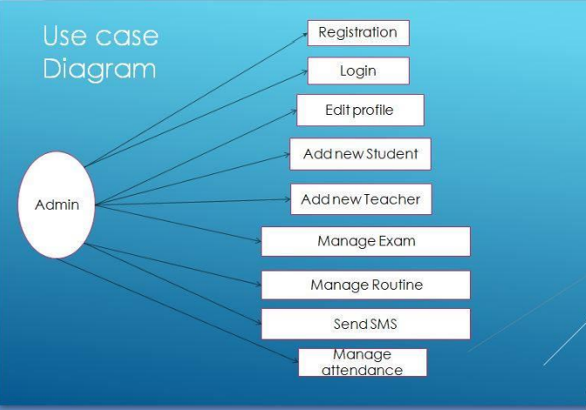
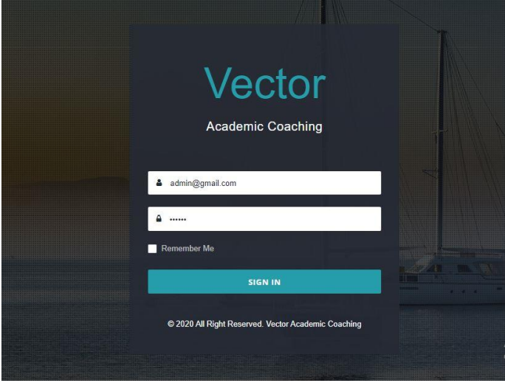
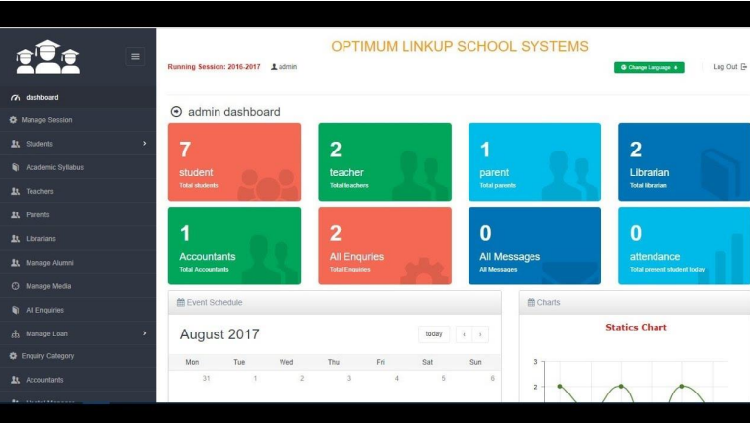

3 Third week internship report
3rd  Week | DATE | DAY | NAME OF THE TOPIC/MODULE COMPLETED
3rd  Week | 01-05-23 | Monday | Developing Project
3rd  Week | 02-05-23 | Tuesday | Developing Project
3rd  Week | 03-05-23 | Wednesday | Developing Project
3rd  Week | 04-05-23 | Thursday | Developing Project
3rd  Week | 05-05-23 | Friday | Developing Project

Advance School management system:
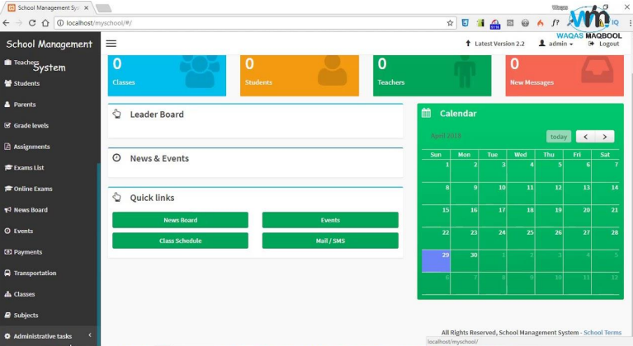

Subject Setup for Students
Admin create and setup the subjects for students.

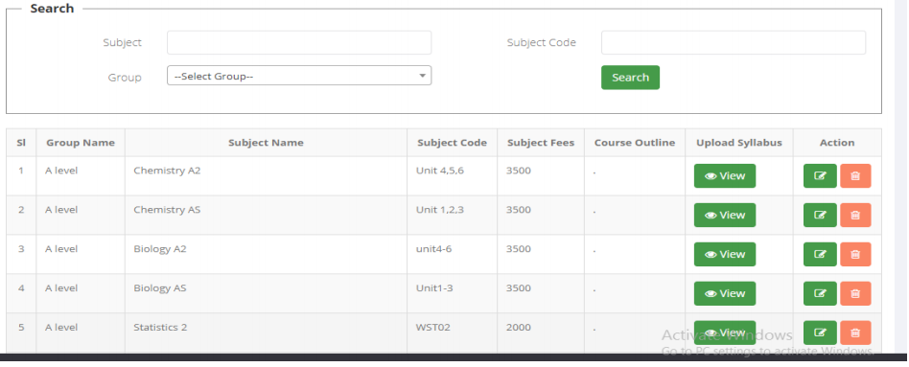

Routine Setup
Admin Setup the routine here and publish for the students. Students can access their routing from the mobile application.
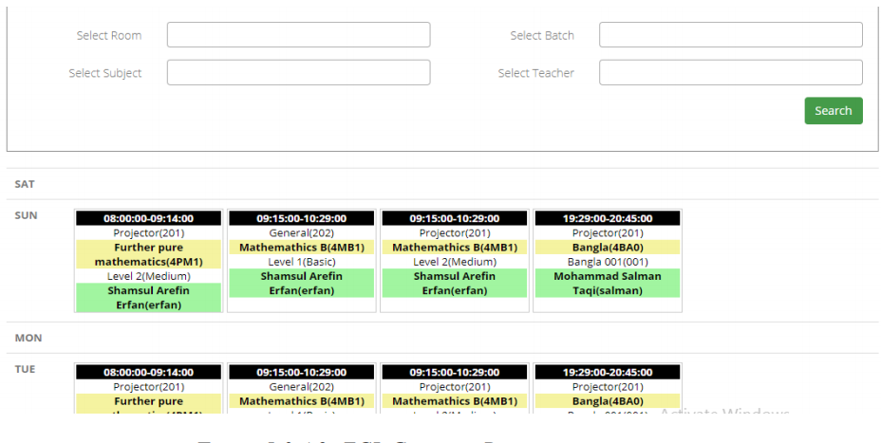

Approval Process:
The admin evaluates the subject selections based on any criteria or requirements set by the institute. They can consider factors such as available seats, prerequisites, or other considerations.
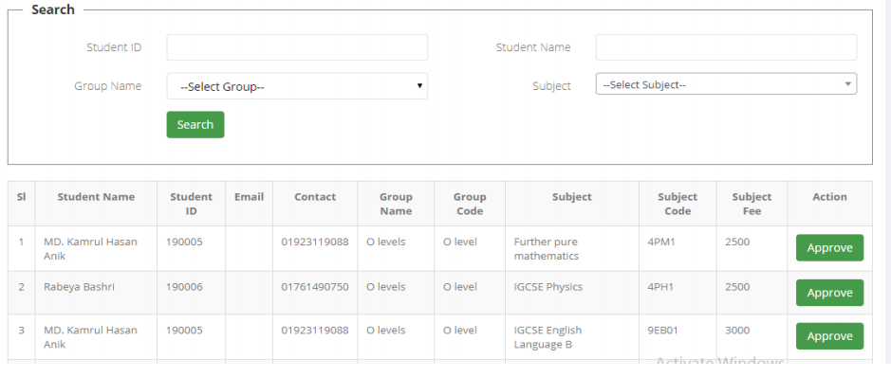

Batch Approval
Admin approve the completed batch here
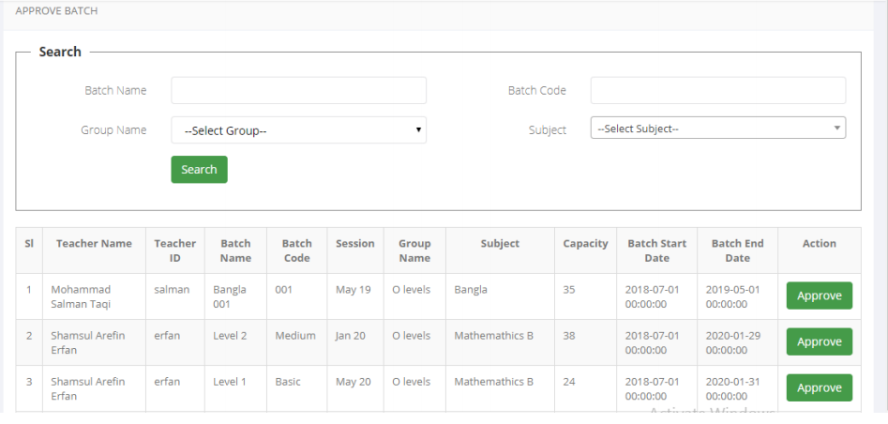

Batch List
Admin can look through the batches both approved and not approved her
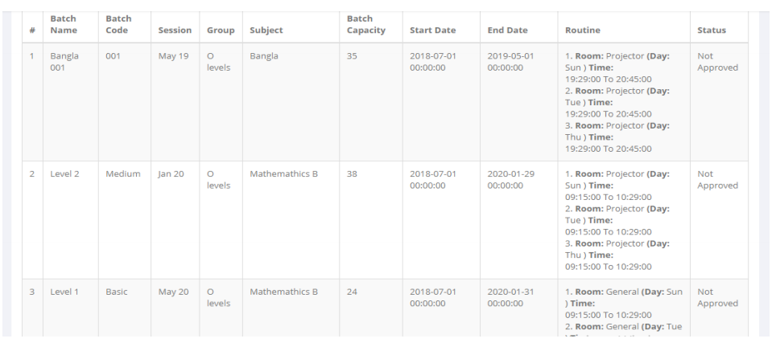

Exam Setup
Admin setup exams for different batches and students get notification on their application also
students can browse the upcoming exams.
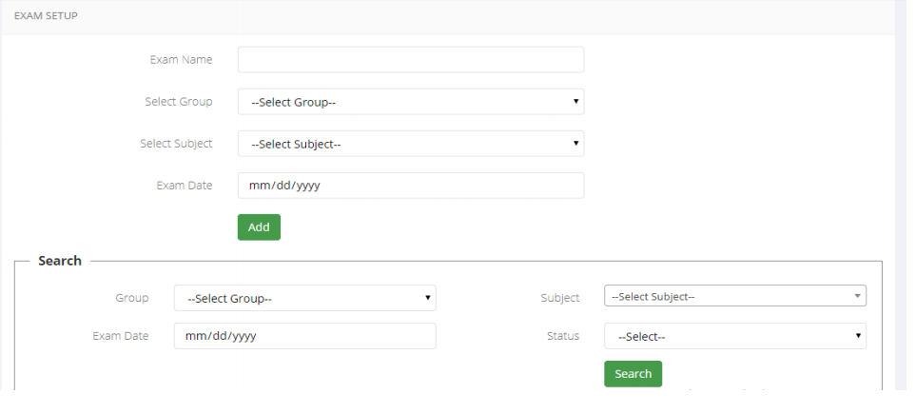

4 Fourth week internship report
4th  Week | DATE | DAY | NAME OF THE TOPIC/MODULE COMPLETED
4th  Week | 08-05-23 | Monday | Developing Project
4th  Week | 09-05-23 | Tuesday | Developing Project
4th  Week | 10-05-23 | Wednesday | Developing Project
4th  Week | 11-05-23 | Thursday | Developing Project
4th  Week | 12-05-23 | Friday | Developing Project

Discount Setup
Discount can initialize for the specific students here from the course

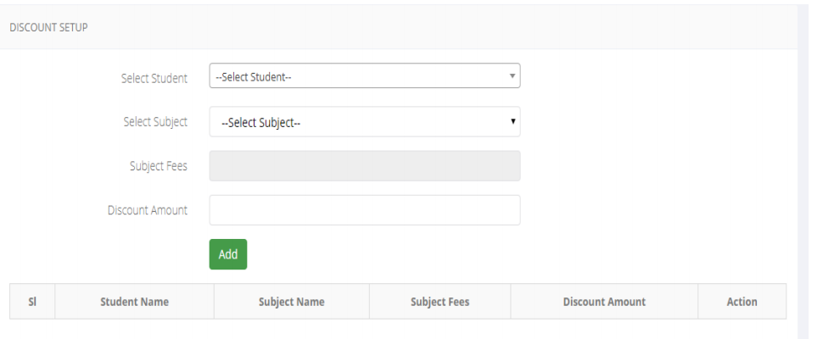

Grade Setup
Subject wise grade publish from here
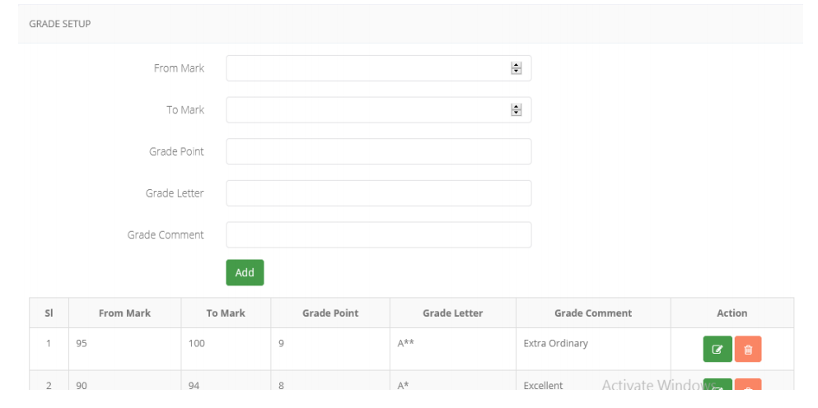
Course Session Setup
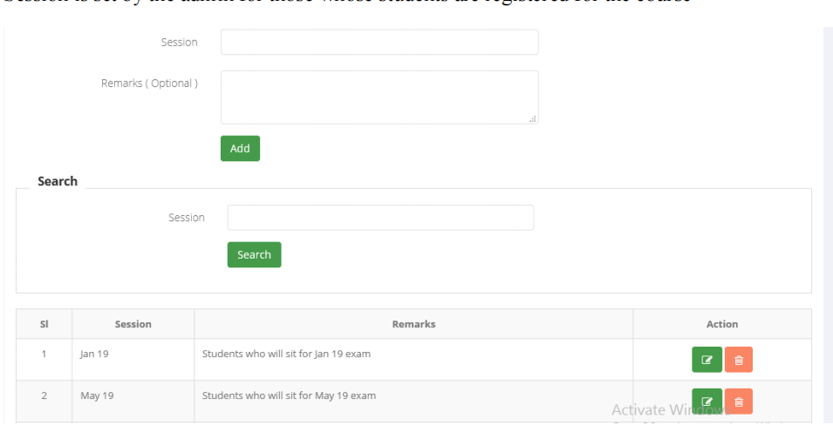
Exam Mark Report
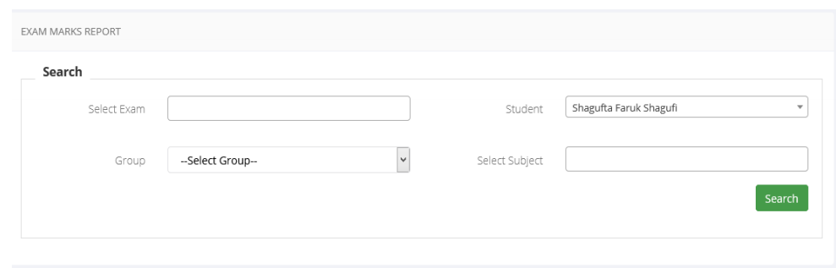

Coding :

class User:
def __init__(self, username, password):
self.username = username
self.password = password

class Subject:
def __init__(self, name):
self.name = name

class CoachingManagement:
def __init__(self):
self.users = []
self.subjects = []
self.students = []

def add_user(self, username, password):
user = User(username, password)
self.users.append(user)
print(f"User {username} has been added.")

def login(self, username, password):
for user in self.users:
if user.username == username and user.password == password:
print(f"User {username} has logged in successfully.")
return True
print("Invalid credentials. Please try again.")
return False

def add_subject(self, name):
subject = Subject(name)
self.subjects.append(subject)
print(f"Subject {name} has been added.")

def approve_student(self, student_name):
for student in self.students:
if student.name == student_name:
student.approved = True
print(f"Student {student_name} has been approved.")
return
print(f"Student {student_name} not found.")

class User:
def __init__(self, username, password):
self.username = username
self.password = password

class Subject:
def __init__(self, name, teacher=None):
self.name = name
self.teacher = teacher

class Student:
def __init__(self, name):
self.name = name
self.enrolled_subjects = []

class Teacher:
def __init__(self, name):
self.name = name

class Quiz:
def __init__(self, subject, questions):
self.subject = subject
self.questions = questions

class CoachingManagement:
def __init__(self):
self.users = []
self.subjects = []
self.students = []
self.teachers = []
self.quizzes = []

def add_user(self, username, password):
user = User(username, password)
self.users.append(user)
print(f"User {username} has been added.")

def login(self, username, password):
for user in self.users:
if user.username == username and user.password == password:
print(f"User {username} has logged in successfully.")
return True
print("Invalid credentials. Please try again.")
return False

def add_subject(self, name, teacher=None):
subject = Subject(name, teacher)
self.subjects.append(subject)
print(f"Subject {name} has been added.")

def display_subjects(self):
print("Available Subjects:")
for subject in self.subjects:
if subject.teacher:
print(f"{subject.name} (Teacher: {subject.teacher.name})")
else:
print(subject.name)

def approve_student(self, student_name):
for student in self.students:
if student.name == student_name:
student.approved = True
print(f"Student {student_name} has been approved.")
return
print(f"Student {student_name} not found.")

def enroll_student(self, student_name, subject_name):
for student in self.students:
if student.name == student_name:
for subject in self.subjects:
if subject.name == subject_name:
student.enrolled_subjects.append(subject)
print(f"Student {student_name} has enrolled in subject {subject_name}.")
return
print(f"Subject {subject_name} not found.")
return
print(f"Student {student_name} not found.")

def add_teacher(self, name):
teacher = Teacher(name)
self.teachers.append(teacher)
print(f"Teacher {name} has been added.")

def assign_teacher(self, subject_name, teacher_name):
for subject in self.subjects:
if subject.name == subject_name:
for teacher in self.teachers:
if teacher.name == teacher_name:
subject.teacher = teacher
print(f"Subject {subject_name} has been assigned to teacher {teacher_name}.")
return
print(f"Teacher {teacher_name} not found.")
return
print(f"Subject {subject_name} not found.")

def add_quiz(self, subject_name, questions):
for subject in self.subjects:
if subject.name == subject_name:
quiz = Quiz(subject, questions)
self.quizzes.append(quiz)
print(f"Quiz added for subject {subject_name}.")
return
print(f"Subject {subject_name} not found.")

class User:
def __init__(self, username, password):
self.username = username
self.password = password

class Subject:
def __init__(self, name, teacher=None):
self.name = name
self.teacher = teacher

class Student:
def __init__(self, name):
self.name = name
self.enrolled_subjects = []
self.approved_batches = []

class Teacher:
def __init__(self, name):
self.name = name

class Batch:
def __init__(self, name, subject):
self.name = name
self.subject = subject
self.students = []

class Exam:
def __init__(self, subject, date):
self.subject = subject
self.date = date

class CoachingManagement:
def __init__(self):
self.users = []
self.subjects = []
self.students = []
self.teachers = []
self.batches = []
self.exams = []

def add_user(self, username, password):
user = User(username, password)
self.users.append(user)
print(f"User {username} has been added.")

def login(self, username, password):
for user in self.users:
if user.username == username and user.password == password:
print(f"User {username} has logged in successfully.")
return True
print("Invalid credentials. Please try again.")
return False

def add_subject(self, name, teacher=None):
subject = Subject(name, teacher)
self.subjects.append(subject)
print(f"Subject {name} has been added.")

def display_subjects(self):
print("Available Subjects:")
for subject in self.subjects:
if subject.teacher:
print(f"{subject.name} (Teacher: {subject.teacher.name})")
else:
print(subject.name)

def approve_student(self, student_name):
for student in self.students:
if student.name == student_name:
student.approved = True
print(f"Student {student_name} has been approved.")
return
print(f"Student {student_name} not found.")

def enroll_student(self, student_name, subject_name):
for student in self.students:
if student.name == student_name:
for subject in self.subjects:
if subject.name == subject_name:
student.enrolled_subjects.append(subject)
print(f"Student {student_name} has enrolled in subject {subject_name}.")
return
print(f"Subject {subject_name} not found.")
return
print(f"Student {student_name} not found.")

def add_teacher(self, name):
teacher = Teacher(name)
self.teachers.append(teacher)
print(f"Teacher {name} has been added.")

def assign_teacher(self, subject_name, teacher_name):
for subject in self.subjects:
if subject.name == subject_name:
for teacher in self.teachers:
if teacher.name == teacher_name:
subject.teacher = teacher
print(f"Subject {subject_name} has been assigned to teacher {teacher_name}.")
return
print(f"Teacher {teacher_name} not found.")
return
print(f"Subject {subject_name} not found.")

def create_batch(self, batch_name, subject_name):
for subject in self.subjects:
if subject.name == subject_name:
batch = Batch(batch_name, subject)
self.batches.append(batch)
print(f"Batch {batch_name} has been created for subject {subject_name}.")
return
print(f"Subject {subject_name} not found.")

def approve_batch(self, batch_name):
for batch in self.batches:
if batch.name == batch_name:
for student in batch.students:
student.approved_batches.append(batch)
print(f"Batch {batch_name} has been approved.")
return
print(f"Batch {batch_name} not found.")

def set_exam(self, subject_name, date):
for subject in self.subjects:
if subject.name == subject_name:
exam = Exam(subject, date)
self.exams.append(exam)
print(f"Exam has been set for subject {subject_name}.")
return
print(f"Subject {subject_name} not found.")

class User:
def __init__(self, username, password):
self.username = username
self.password = password

class Subject:
def __init__(self, name, teacher=None):
self.name = name
self.teacher = teacher

class Student:
def __init__(self, name):
self.name = name
self.enrolled_subjects = []
self.approved_batches = []

class Teacher:
def __init__(self, name):
self.name = name

class Batch:
def __init__(self, name, subject):
self.name = name
self.subject = subject
self.students = []

class Exam:
def __init__(self, subject, date):
self.subject = subject
self.date = date

class Grade:
def __init__(self, name, min_marks, max_marks):
self.name = name
self.min_marks = min_marks
self.max_marks = max_marks

class Session:
def __init__(self, name, subject, start_date, end_date):
self.name = name
self.subject = subject
self.start_date = start_date
self.end_date = end_date

class MarkReport:
def __init__(self, student, subject, marks):
self.student = student
self.subject = subject
self.marks = marks

class CoachingManagement:
def __init__(self):
self.users = []
self.subjects = []
self.students = []
self.teachers = []
self.batches = []
self.exams = []
self.grades = []
self.sessions = []
self.mark_reports = []

def add_user(self, username, password):
user = User(username, password)
self.users.append(user)
print(f"User {username} has been added.")

def login(self, username, password):
for user in self.users:
if user.username == username and user.password == password:
print(f"User {username} has logged in successfully.")
return True
print("Invalid credentials. Please try again.")
return False

def add_subject(self, name, teacher=None):
subject = Subject(name, teacher)
self.subjects.append(subject)
print(f"Subject {name} has been added.")

def display_subjects(self):
print("Available Subjects:")
for subject in self.subjects:
if subject.teacher:
print(f"{subject.name} (Teacher: {subject.teacher.name})")
else:
print(subject.name)

def approve_student(self, student_name):
for student in self.students:
if student.name == student_name:
student.approved = True
print(f"Student {student_name} has been approved.")
return
print(f"Student {student_name} not found.")

def enroll_student(self, student_name, subject_name):
for student in self.students:
if student.name == student_name:
for subject in self.subjects:
if subject.name == subject_name:
student.enrolled_subjects.append(subject)
print(f"Student {student_name} has enrolled in subject {subject_name}.")
return
print(f"Subject {subject_name} not found.")
return
print(f"Student {student_name} not found.")

def add_teacher(self, name):
teacher = Teacher(name)
self.teachers.append(teacher)
print(f"Teacher {name} has been added.")

def assign_teacher(self, subject_name, teacher_name):
for subject in self.subjects:
if subject.name == subject_name:
for teacher in self.teachers:
if teacher.name == teacher_name:
subject.teacher = teacher
print(f"Subject {subject_name} has been assigned to teacher {teacher_name}.")
return
print(f"Teacher {teacher_name} not found.")
return
print(f"Subject {subject_name} not found.")

def create_batch(self, batch_name, subject_name):
for subject in self.subjects:
if subject.name == subject_name:
batch = Batch(batch_name, subject)
self.batches.append(batch)
print(f"Batch {batch_name} has been created for subject {subject_name}.")
return
print(f"Subject {subject_name} not found.")

def approve_batch(self, batch_name):
for batch in self.batches:
if batch.name == batch_name:
for student in batch.students:
student.approved_batches.append(batch)
print(f"Batch {batch_name} has been approved.")
return
print(f"Batch {batch_name} not found.")

def set_exam(self, subject_name, date):
for subject in self.subjects:
if subject.name == subject_name:
exam = Exam(subject, date)
self.exams.append(exam)
print(f"Exam has been set for subject {subject_name}.")
return
print(f"Subject {subject_name} not found.")

def add_grade(self, name, min_marks, max_marks):
grade = Grade(name, min_marks, max_marks)
self.grades.append(grade)
print(f"Grade {name} has been added.")

def add_session(self, name, subject_name, start_date, end_date):
for subject in self.subjects:
if subject.name == subject_name:
session = Session(name, subject, start_date, end_date)
self.sessions.append(session)
print(f"Session {name} has been added for subject {subject_name}.")
return
print(f"Subject {subject_name} not found.")

def add_mark_report(self, student_name, subject_name, marks):
for student in self.students:
if student.name == student_name:
for subject in self.subjects:
if subject.name == subject_name:
mark_report = MarkReport(student, subject, marks)
self.mark_reports.append(mark_report)
print(f"Mark report added for student {student_name} in subject {subject_name}.")
return
print(f"Subject {subject_name} not found.")
return
print(f"Student {student_name} not found.")

5 Internship summary
During my internship at IsDB , a renowned software company, I had the opportunity to gain practical experience and valuable insights into the industry. As an undergraduate student pursuing a degree in Software Engineering, this internship was a crucial step towards bridging the gap between theory and real-world application.

Throughout my internship, which lasted for one month, I was assigned to the project "Making a website for ELC (English Medium Coaching)". This project involved developing and designing a management software specifically tailored for a coaching institute. My responsibilities included collaborating with a team of professionals to coordinate and manage the project according to the software development life cycle.

Working on this project exposed me to various aspects of software development, such as requirement gathering, coding, testing, and documentation. I gained hands-on experience in utilizing industry-standard tools and technologies to create a user-friendly and efficient software solution. Moreover, I had the opportunity to work closely with experienced developers, learning from their expertise and incorporating their guidance into my work.

Beyond technical skills, my internship at IsDB provided a platform to cultivate essential soft skills. I learned the importance of effective communication, teamwork, and adaptability in a professional setting. I also developed a strong work ethic, meeting project deadlines and embracing new challenges with enthusiasm.

The internship experience at IsDB not only enriched my academic knowledge but also broadened my horizons regarding the software industry. Witnessing the company's good reputation both locally and abroad further instilled confidence in the quality of work and the impact it can have.

I am immensely grateful to IsDB for providing me with this valuable opportunity to grow as a software engineer. This internship has significantly contributed to my personal and professional development, equipping me with the skills and experience necessary to thrive in the industry. I look forward to applying the knowledge and insights gained from this internship to future endeavors, as I continue to pursue excellence in the field of software engineering.

Internship report score sheet
Sequence number | Rating items | Maximum score | score
a | The internship study attitude is serious, and the report meets the template requirements; | 10
b | The report content is comprehensive and the internship process is complete; | 30
c | In-depth analysis of learning content, with unique insights and strong practical ability; | 30
d | Practical tasks completed well； | 20
e | The report is well illustrated and well typed. | 10
 |  | Total score

Thank You

